**PLAYFINITY**

**Word Report:**

**Uwaid Munir 23i 2574 ( 2 category webpages)**

Description:

I started off with the basic html and tags.

I created classes so i can use them again and can be stled in css.

i stared off the page with the name of our website, our website's name in the title and our logo.

I than named my categories in my both Pages and added a picture in the start to give a overview on how the games in my category look.

I also gave a little idea and description about the games in the related categories of mine.

After all these things i added the icons of my games. I used the hover function to make it look more stylish and immersive.

the hover function works in the following way that when the cursor is brought on the icon the name, developer, size and other data and information about the games is shown.

i included 9 games per page so it looks like a 3x3 Grid.

Made two pages i.e sports and horror categories

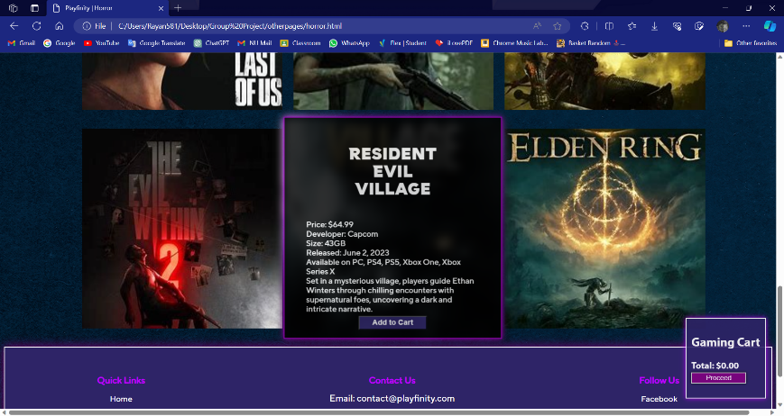

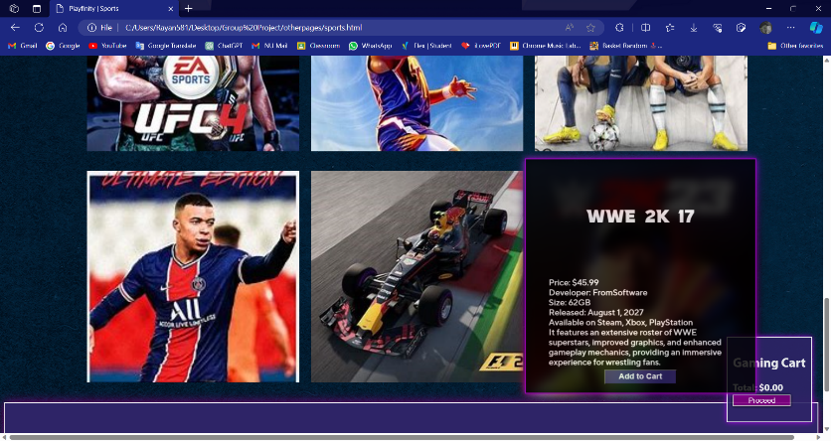

**Abdul Rehman 23i 2082 (login and register page and two webpages)**

Description:

Login page

user input pass or username if both are equal to actual username or password then login succesful or go to home page

else it says that wrong password is entered

By clicking “Forget password” user can recover his account by email

By clicking register “Register” window will open and user can register if he wants to .

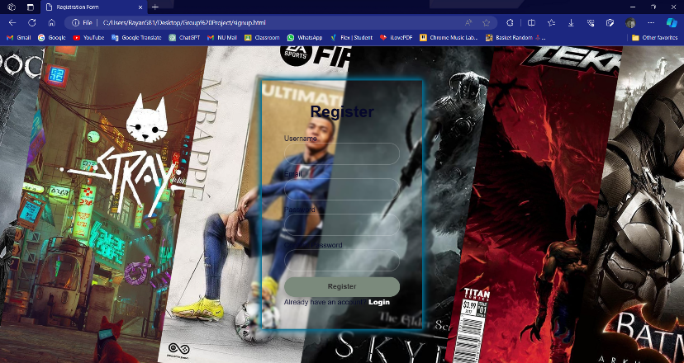

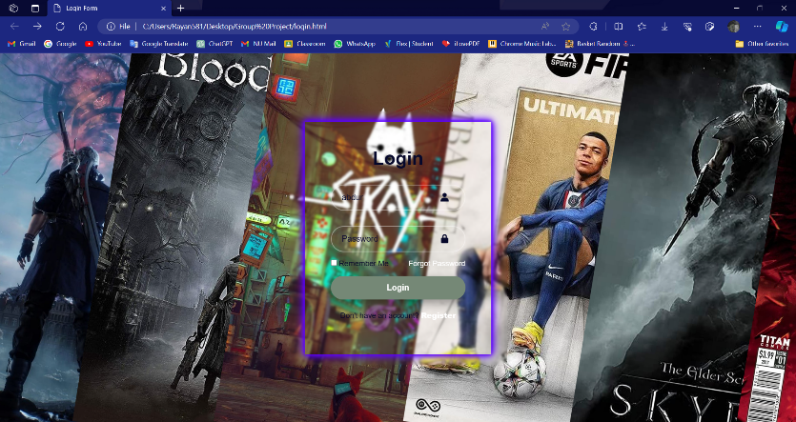

Webpages:

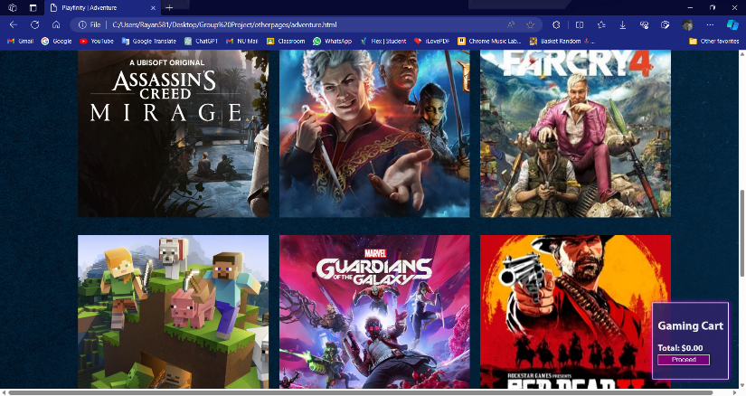

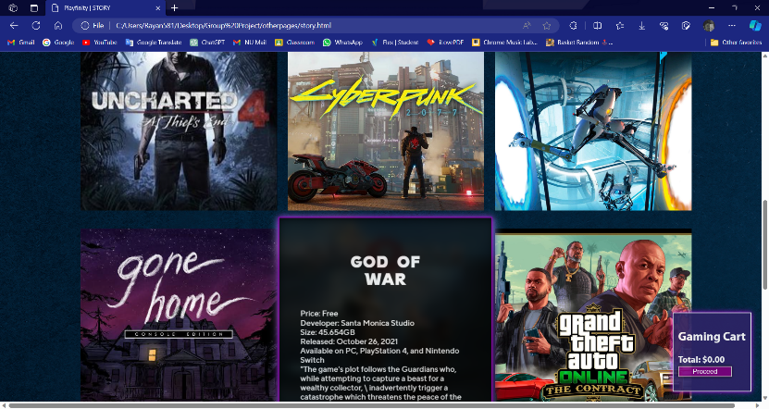

Desription :

Hover to display information

Add to cart function by Java script

Added game icons.

Used ids for adding to cart.

**Rayan 23i 0018 (Home page & catergories webpages)**

Desription :

Hover to display information

Add to cart function by Java script

Added game icons.

Used ids for adding to cart.

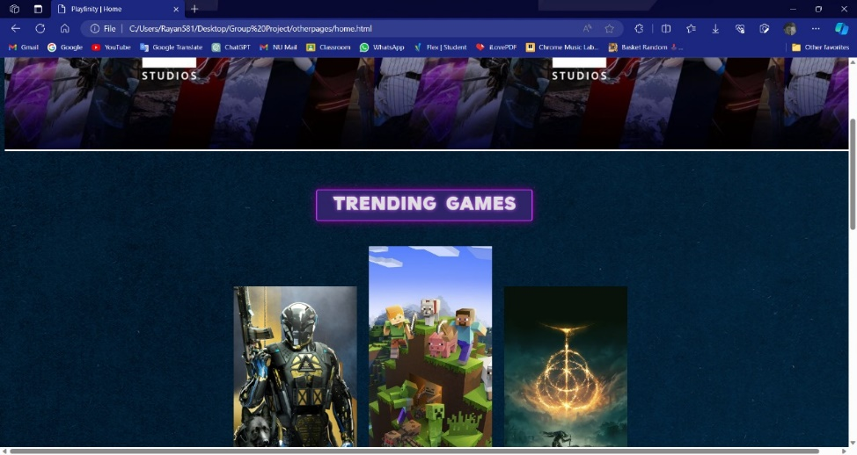

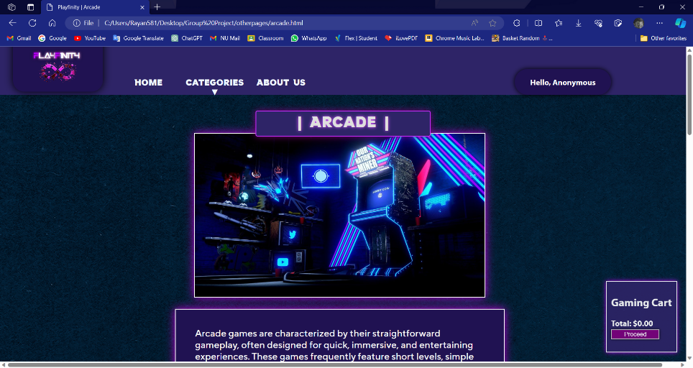

**Ahmed Hassan 23i 0059**

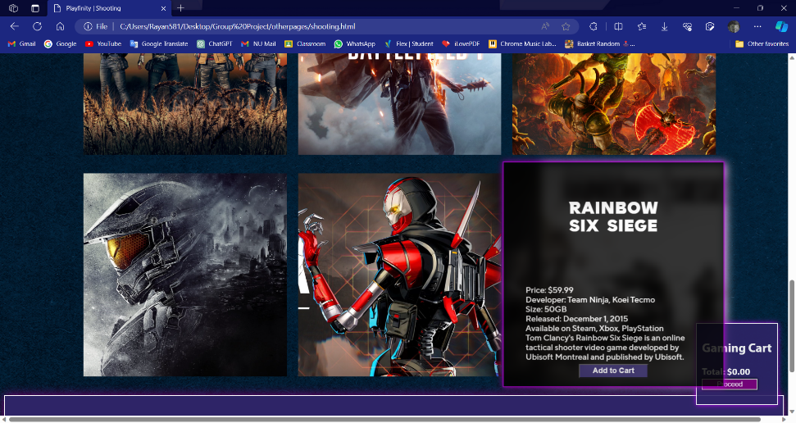

Hover to display information

Add to cart function by Java script

Added game icons.

Used ids for adding to cart.

**Cart By Ahmed Hassan :**

* aritmetic operations on adding and removing items on cart
* display of final updated ammount
* display of payment method

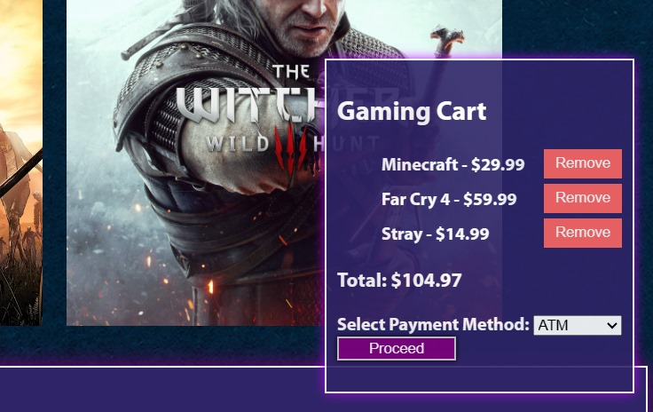

**Amna Hameed 23i 0102 ( 2 category web pages) :**

Description:

Hover to display information

Add to cart function by Java script

Added game icons.

Used ids for adding to cart.

